**MODUL 11 PEMROGRAMAN BERORIENTASI OBJEK**

**DATABASE ACCESS (JDBC)**

1. **Database**

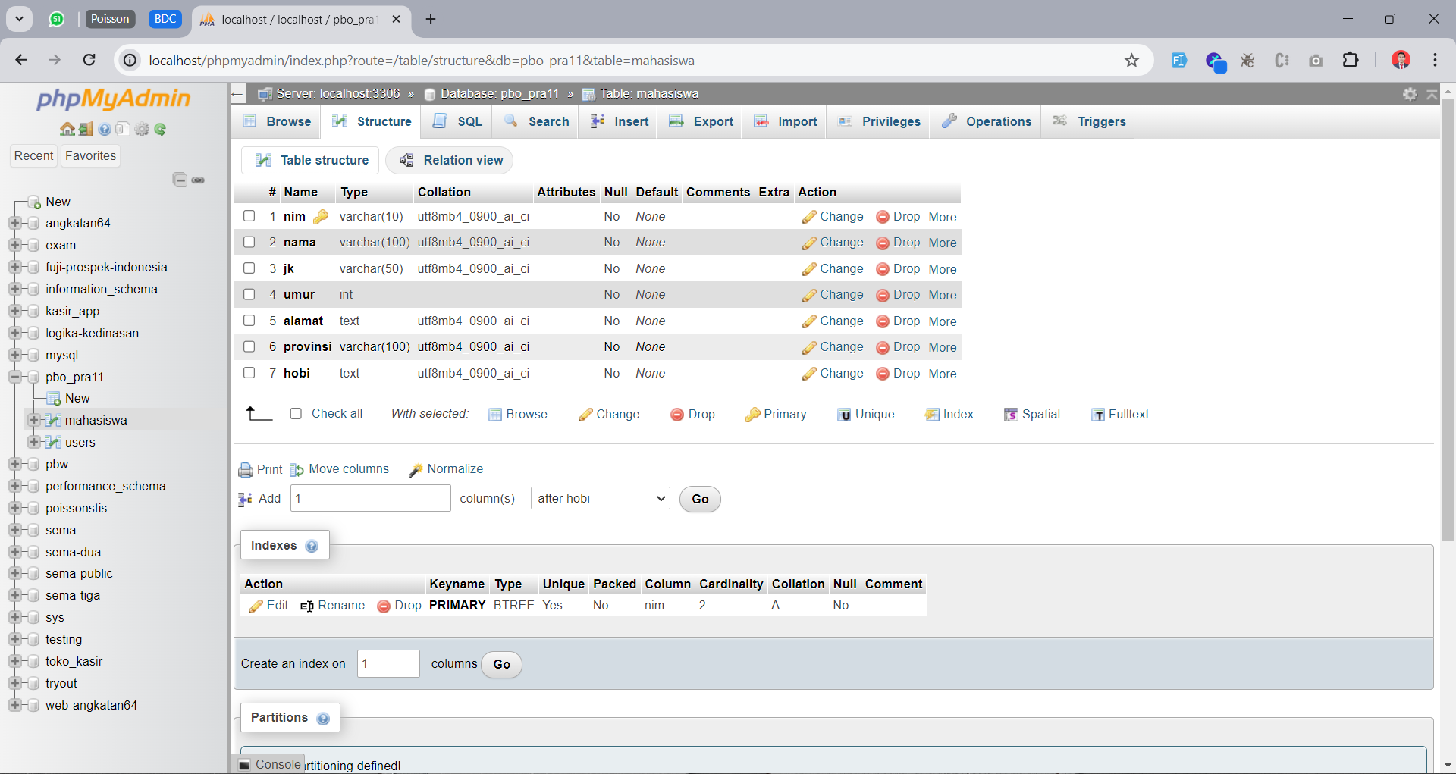

1. **Menambah MySQL Connector Java ke Project**

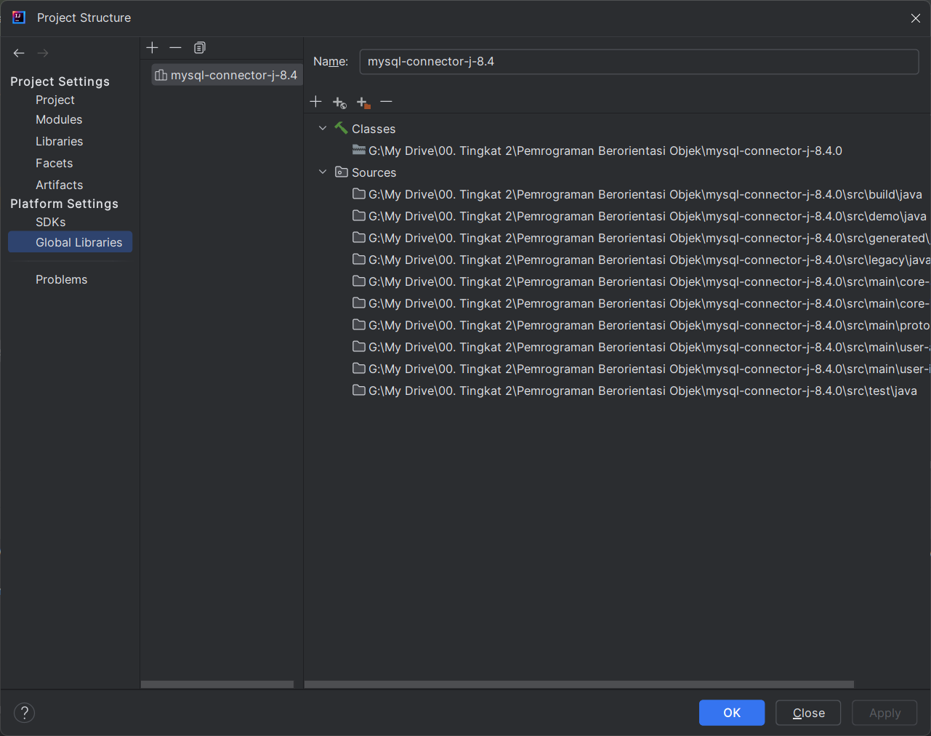

1. **Source Code**
2. EntryPanel.java

/*  
 * Click nbfs://nbhost/SystemFileSystem/Templates/Licenses/license-default.txt to change this license  
 * Click nbfs://nbhost/SystemFileSystem/Templates/GUIForms/JPanel.java to edit this template  
 */  
package latihan.gui;  
  
import java.sql.SQLException;  
import java.util.ArrayList;  
import javax.swing.JOptionPane;  
import javax.swing.table.DefaultTableModel;  
  
*/**  
 *  
 * @author muham  
 */*public class EntryPanel extends javax.swing.JPanel {  
  
 */**  
 * Creates new form EntryPanel  
 */* public EntryPanel() {  
 initComponents();  
 loadTableData();  
 }  
  
 */**  
 * This method is called from within the constructor to initialize the form.  
 * WARNING: Do NOT modify this code. The content of this method is always  
 * regenerated by the Form Editor.  
 */* @SuppressWarnings("unchecked")  
 // <editor-fold defaultstate="collapsed" desc="Generated Code">//GEN-BEGIN:initComponents  
 private void initComponents() {  
  
 jkButtonGroup = new javax.swing.ButtonGroup();  
 jPanel1 = new javax.swing.JPanel();  
 jLabel5 = new javax.swing.JLabel();  
 jLabel6 = new javax.swing.JLabel();  
 jScrollPane1 = new javax.swing.JScrollPane();  
 alamatTextArea = new javax.swing.JTextArea();  
 jLabel7 = new javax.swing.JLabel();  
 provinsiComboBox = new javax.swing.JComboBox<>();  
 jLabel8 = new javax.swing.JLabel();  
 membacaCheckBox = new javax.swing.JCheckBox();  
 menyanyiCheckBox = new javax.swing.JCheckBox();  
 jLabel1 = new javax.swing.JLabel();  
 jLabel2 = new javax.swing.JLabel();  
 jLabel3 = new javax.swing.JLabel();  
 nimTextField = new javax.swing.JTextField();  
 namaTextField = new javax.swing.JTextField();  
 lakiRadioButton = new javax.swing.JRadioButton();  
 perempuanRadioButton = new javax.swing.JRadioButton();  
 jLabel4 = new javax.swing.JLabel();  
 berenangCheckBox = new javax.swing.JCheckBox();  
 umurSpinner = new javax.swing.JSpinner();  
 simpanButton = new javax.swing.JButton();  
 jPanel2 = new javax.swing.JPanel();  
 jScrollPane2 = new javax.swing.JScrollPane();  
 mahasiswaTable = new javax.swing.JTable();  
  
 setLayout(new java.awt.BorderLayout());  
  
 jLabel5.setText("tahun");  
  
 jLabel6.setText("Alamat :");  
  
 alamatTextArea.setColumns(20);  
 alamatTextArea.setRows(5);  
 jScrollPane1.setViewportView(alamatTextArea);  
  
 jLabel7.setText("Provinsi :");  
  
 provinsiComboBox.setModel(new javax.swing.DefaultComboBoxModel<>(new String[] { "Aceh", "DKI Jakarta", "Jawa Timur", "Bali", "Maluku", "Papua" }));  
  
 jLabel8.setText("Hobi :");  
  
 membacaCheckBox.setText("Membaca");  
  
 menyanyiCheckBox.setText("Menyanyi");  
  
 jLabel1.setText("NIM :");  
  
 jLabel2.setText("Jenis Kelamin :");  
  
 jLabel3.setText("Nama :");  
  
 jkButtonGroup.add(lakiRadioButton);  
 lakiRadioButton.setText("Laki-laki");  
  
 jkButtonGroup.add(perempuanRadioButton);  
 perempuanRadioButton.setText("Perempuan");  
  
 jLabel4.setText("Umur :");  
  
 berenangCheckBox.setText("Berenang");  
  
 umurSpinner.setModel(new javax.swing.SpinnerNumberModel(15, 10, 60, 1));  
  
 simpanButton.setText("Simpan");  
 simpanButton.addActionListener(new java.awt.event.ActionListener() {  
 public void actionPerformed(java.awt.event.ActionEvent evt) {  
 simpanButtonActionPerformed(evt);  
 }  
 });  
  
 javax.swing.GroupLayout jPanel1Layout = new javax.swing.GroupLayout(jPanel1);  
 jPanel1.setLayout(jPanel1Layout);  
 jPanel1Layout.setHorizontalGroup(  
 jPanel1Layout.createParallelGroup(javax.swing.GroupLayout.Alignment.*LEADING*)  
 .addGap(0, 342, Short.*MAX_VALUE*)  
 .addGroup(jPanel1Layout.createParallelGroup(javax.swing.GroupLayout.Alignment.*LEADING*)  
 .addGroup(jPanel1Layout.createSequentialGroup()  
 .addGap(13, 13, 13)  
 .addGroup(jPanel1Layout.createParallelGroup(javax.swing.GroupLayout.Alignment.*TRAILING*)  
 .addComponent(simpanButton)  
 .addGroup(jPanel1Layout.createSequentialGroup()  
 .addGroup(jPanel1Layout.createParallelGroup(javax.swing.GroupLayout.Alignment.*LEADING*, false)  
 .addComponent(jLabel1, javax.swing.GroupLayout.*DEFAULT_SIZE*, javax.swing.GroupLayout.*DEFAULT_SIZE*, Short.*MAX_VALUE*)  
 .addComponent(jLabel2, javax.swing.GroupLayout.*DEFAULT_SIZE*, javax.swing.GroupLayout.*DEFAULT_SIZE*, Short.*MAX_VALUE*)  
 .addComponent(jLabel3, javax.swing.GroupLayout.Alignment.*TRAILING*, javax.swing.GroupLayout.*DEFAULT_SIZE*, 83, Short.*MAX_VALUE*)  
 .addComponent(jLabel4, javax.swing.GroupLayout.*DEFAULT_SIZE*, javax.swing.GroupLayout.*DEFAULT_SIZE*, Short.*MAX_VALUE*)  
 .addComponent(jLabel6, javax.swing.GroupLayout.Alignment.*TRAILING*, javax.swing.GroupLayout.*DEFAULT_SIZE*, javax.swing.GroupLayout.*DEFAULT_SIZE*, Short.*MAX_VALUE*)  
 .addComponent(jLabel7, javax.swing.GroupLayout.*DEFAULT_SIZE*, javax.swing.GroupLayout.*DEFAULT_SIZE*, Short.*MAX_VALUE*)  
 .addComponent(jLabel8, javax.swing.GroupLayout.*DEFAULT_SIZE*, javax.swing.GroupLayout.*DEFAULT_SIZE*, Short.*MAX_VALUE*))  
 .addPreferredGap(javax.swing.LayoutStyle.ComponentPlacement.*RELATED*)  
 .addGroup(jPanel1Layout.createParallelGroup(javax.swing.GroupLayout.Alignment.*LEADING*)  
 .addComponent(berenangCheckBox, javax.swing.GroupLayout.*PREFERRED_SIZE*, 85, javax.swing.GroupLayout.*PREFERRED_SIZE*)  
 .addComponent(menyanyiCheckBox, javax.swing.GroupLayout.*PREFERRED_SIZE*, 85, javax.swing.GroupLayout.*PREFERRED_SIZE*)  
 .addGroup(jPanel1Layout.createParallelGroup(javax.swing.GroupLayout.Alignment.*LEADING*, false)  
 .addComponent(perempuanRadioButton, javax.swing.GroupLayout.*PREFERRED_SIZE*, 98, javax.swing.GroupLayout.*PREFERRED_SIZE*)  
 .addComponent(lakiRadioButton, javax.swing.GroupLayout.*PREFERRED_SIZE*, 98, javax.swing.GroupLayout.*PREFERRED_SIZE*)  
 .addComponent(namaTextField, javax.swing.GroupLayout.*DEFAULT_SIZE*, 154, Short.*MAX_VALUE*)  
 .addComponent(nimTextField))  
 .addGroup(jPanel1Layout.createSequentialGroup()  
 .addComponent(umurSpinner, javax.swing.GroupLayout.*PREFERRED_SIZE*, javax.swing.GroupLayout.*DEFAULT_SIZE*, javax.swing.GroupLayout.*PREFERRED_SIZE*)  
 .addPreferredGap(javax.swing.LayoutStyle.ComponentPlacement.*RELATED*)  
 .addComponent(jLabel5, javax.swing.GroupLayout.*PREFERRED_SIZE*, 39, javax.swing.GroupLayout.*PREFERRED_SIZE*))  
 .addComponent(jScrollPane1, javax.swing.GroupLayout.*PREFERRED_SIZE*, javax.swing.GroupLayout.*DEFAULT_SIZE*, javax.swing.GroupLayout.*PREFERRED_SIZE*)  
 .addComponent(provinsiComboBox, javax.swing.GroupLayout.*PREFERRED_SIZE*, 92, javax.swing.GroupLayout.*PREFERRED_SIZE*)  
 .addComponent(membacaCheckBox, javax.swing.GroupLayout.*PREFERRED_SIZE*, 85, javax.swing.GroupLayout.*PREFERRED_SIZE*))))  
 .addContainerGap(javax.swing.GroupLayout.*DEFAULT_SIZE*, Short.*MAX_VALUE*)))  
 );  
 jPanel1Layout.setVerticalGroup(  
 jPanel1Layout.createParallelGroup(javax.swing.GroupLayout.Alignment.*LEADING*)  
 .addGap(0, 439, Short.*MAX_VALUE*)  
 .addGroup(jPanel1Layout.createParallelGroup(javax.swing.GroupLayout.Alignment.*LEADING*)  
 .addGroup(jPanel1Layout.createSequentialGroup()  
 .addContainerGap()  
 .addGroup(jPanel1Layout.createParallelGroup(javax.swing.GroupLayout.Alignment.*BASELINE*)  
 .addComponent(jLabel1)  
 .addComponent(nimTextField, javax.swing.GroupLayout.*PREFERRED_SIZE*, javax.swing.GroupLayout.*DEFAULT_SIZE*, javax.swing.GroupLayout.*PREFERRED_SIZE*))  
 .addPreferredGap(javax.swing.LayoutStyle.ComponentPlacement.*UNRELATED*)  
 .addGroup(jPanel1Layout.createParallelGroup(javax.swing.GroupLayout.Alignment.*BASELINE*)  
 .addComponent(jLabel3)  
 .addComponent(namaTextField, javax.swing.GroupLayout.*PREFERRED_SIZE*, javax.swing.GroupLayout.*DEFAULT_SIZE*, javax.swing.GroupLayout.*PREFERRED_SIZE*))  
 .addPreferredGap(javax.swing.LayoutStyle.ComponentPlacement.*UNRELATED*)  
 .addGroup(jPanel1Layout.createParallelGroup(javax.swing.GroupLayout.Alignment.*BASELINE*)  
 .addComponent(jLabel2)  
 .addComponent(lakiRadioButton))  
 .addPreferredGap(javax.swing.LayoutStyle.ComponentPlacement.*RELATED*)  
 .addComponent(perempuanRadioButton)  
 .addPreferredGap(javax.swing.LayoutStyle.ComponentPlacement.*RELATED*)  
 .addGroup(jPanel1Layout.createParallelGroup(javax.swing.GroupLayout.Alignment.*BASELINE*)  
 .addComponent(jLabel4)  
 .addComponent(umurSpinner, javax.swing.GroupLayout.*PREFERRED_SIZE*, javax.swing.GroupLayout.*DEFAULT_SIZE*, javax.swing.GroupLayout.*PREFERRED_SIZE*)  
 .addComponent(jLabel5))  
 .addPreferredGap(javax.swing.LayoutStyle.ComponentPlacement.*UNRELATED*)  
 .addGroup(jPanel1Layout.createParallelGroup(javax.swing.GroupLayout.Alignment.*LEADING*)  
 .addComponent(jLabel6)  
 .addComponent(jScrollPane1, javax.swing.GroupLayout.*PREFERRED_SIZE*, javax.swing.GroupLayout.*DEFAULT_SIZE*, javax.swing.GroupLayout.*PREFERRED_SIZE*))  
 .addGap(7, 7, 7)  
 .addGroup(jPanel1Layout.createParallelGroup(javax.swing.GroupLayout.Alignment.*BASELINE*)  
 .addComponent(jLabel7)  
 .addComponent(provinsiComboBox, javax.swing.GroupLayout.*PREFERRED_SIZE*, javax.swing.GroupLayout.*DEFAULT_SIZE*, javax.swing.GroupLayout.*PREFERRED_SIZE*))  
 .addPreferredGap(javax.swing.LayoutStyle.ComponentPlacement.*UNRELATED*)  
 .addGroup(jPanel1Layout.createParallelGroup(javax.swing.GroupLayout.Alignment.*LEADING*)  
 .addComponent(jLabel8)  
 .addComponent(membacaCheckBox))  
 .addPreferredGap(javax.swing.LayoutStyle.ComponentPlacement.*RELATED*)  
 .addComponent(menyanyiCheckBox)  
 .addPreferredGap(javax.swing.LayoutStyle.ComponentPlacement.*RELATED*)  
 .addComponent(berenangCheckBox)  
 .addGap(18, 18, 18)  
 .addComponent(simpanButton)  
 .addContainerGap(37, Short.*MAX_VALUE*)))  
 );  
  
 add(jPanel1, java.awt.BorderLayout.*LINE_START*);  
  
 mahasiswaTable.setModel(new javax.swing.table.DefaultTableModel(  
 new Object [][] {  
  
 },  
 new String [] {  
 "NIM", "Nama", "Jenis Kelamin", "Umur"  
 }  
 ) {  
 Class[] types = new Class [] {  
 java.lang.String.class, java.lang.String.class, java.lang.String.class, java.lang.Integer.class  
 };  
 boolean[] canEdit = new boolean [] {  
 false, false, false, false  
 };  
  
 public Class getColumnClass(int columnIndex) {  
 return types [columnIndex];  
 }  
  
 public boolean isCellEditable(int rowIndex, int columnIndex) {  
 return canEdit [columnIndex];  
 }  
 });  
 jScrollPane2.setViewportView(mahasiswaTable);  
  
 javax.swing.GroupLayout jPanel2Layout = new javax.swing.GroupLayout(jPanel2);  
 jPanel2.setLayout(jPanel2Layout);  
 jPanel2Layout.setHorizontalGroup(  
 jPanel2Layout.createParallelGroup(javax.swing.GroupLayout.Alignment.*LEADING*)  
 .addGap(0, 467, Short.*MAX_VALUE*)  
 .addGroup(jPanel2Layout.createParallelGroup(javax.swing.GroupLayout.Alignment.*LEADING*)  
 .addGroup(javax.swing.GroupLayout.Alignment.*TRAILING*, jPanel2Layout.createSequentialGroup()  
 .addContainerGap(9, Short.*MAX_VALUE*)  
 .addComponent(jScrollPane2, javax.swing.GroupLayout.*PREFERRED_SIZE*, javax.swing.GroupLayout.*DEFAULT_SIZE*, javax.swing.GroupLayout.*PREFERRED_SIZE*)  
 .addContainerGap()))  
 );  
 jPanel2Layout.setVerticalGroup(  
 jPanel2Layout.createParallelGroup(javax.swing.GroupLayout.Alignment.*LEADING*)  
 .addGap(0, 439, Short.*MAX_VALUE*)  
 .addGroup(jPanel2Layout.createParallelGroup(javax.swing.GroupLayout.Alignment.*LEADING*)  
 .addGroup(jPanel2Layout.createSequentialGroup()  
 .addContainerGap()  
 .addComponent(jScrollPane2, javax.swing.GroupLayout.*PREFERRED_SIZE*, javax.swing.GroupLayout.*DEFAULT_SIZE*, javax.swing.GroupLayout.*PREFERRED_SIZE*)  
 .addContainerGap(javax.swing.GroupLayout.*DEFAULT_SIZE*, Short.*MAX_VALUE*)))  
 );  
  
 add(jPanel2, java.awt.BorderLayout.*CENTER*);  
 }// </editor-fold>//GEN-END:initComponents  
  
 private void simpanButtonActionPerformed(java.awt.event.ActionEvent evt) {//GEN-FIRST:event_simpanButtonActionPerformed  
 // *TODO add your handling code here:* Mahasiswa mhs = new Mahasiswa();  
 mhs.setNim(nimTextField.getText());  
 mhs.setNama(namaTextField.getText());  
 if(lakiRadioButton.isSelected()) {  
 mhs.setJenisKelamin("Laki-laki");  
 }  
 if(perempuanRadioButton.isSelected()) {  
 mhs.setJenisKelamin("Perempuan");  
 }  
 int umur = (Integer) umurSpinner.getValue();  
 mhs.setUmur(umur);  
 mhs.setAlamat(alamatTextArea.getText());  
  
 mhs.setProvinsi(provinsiComboBox.getSelectedItem().toString());  
 ArrayList<String> hobiList = new ArrayList<>();  
 if(membacaCheckBox.isSelected()) {  
 hobiList.add("membaca");  
 }  
 if(menyanyiCheckBox.isSelected()) {  
 hobiList.add("menyanyi");  
 }  
 if(berenangCheckBox.isSelected()) {  
 hobiList.add("berenang");  
 }  
 mhs.setHobi(hobiList);  
  
 try {  
 Database.*getInstance*().insertMahasiswa(mhs);  
 clearForm();  
 JOptionPane.*showMessageDialog*(this, "Sukses Tersimpan");  
 loadTableData();  
 } catch (SQLException e) {  
 System.*err*.println(e);  
 JOptionPane.*showMessageDialog*(this, "Gagal menyimpan data", "Gagal", JOptionPane.*ERROR_MESSAGE*);  
 }  
 }//GEN-LAST:event_simpanButtonActionPerformed  
  
 private void loadTableData() {  
 DefaultTableModel dtm = (DefaultTableModel) mahasiswaTable.getModel();  
   
 //refresh table  
 while(dtm.getRowCount() > 0) {  
 dtm.removeRow(0);  
 }  
   
 //isi tabel  
 try {  
 for(Mahasiswa mhs : Database.*getInstance*().getListMahasiswa()) {  
 dtm.addRow(new Object[]{mhs.getNim(), mhs.getNama(), mhs.getJenisKelamin(), mhs.getUmur()});  
 }  
 } catch (SQLException e) {  
 System.*err*.println(e);  
 JOptionPane.*showMessageDialog*(this, "Gagal mengambil data.", "Gagal", JOptionPane.*ERROR_MESSAGE*);  
 }  
 }  
   
 private void clearForm() {  
 nimTextField.setText("");  
 namaTextField.setText("");  
 jkButtonGroup.clearSelection();  
 umurSpinner.setValue(15);  
 alamatTextArea.setText("");  
 provinsiComboBox.setSelectedItem(-1);  
 membacaCheckBox.setSelected(false);  
 menyanyiCheckBox.setSelected(false);  
 berenangCheckBox.setSelected(false);  
 }  
   
  
 // Variables declaration - do not modify//GEN-BEGIN:variables  
 private javax.swing.JTextArea alamatTextArea;  
 private javax.swing.JCheckBox berenangCheckBox;  
 private javax.swing.JLabel jLabel1;  
 private javax.swing.JLabel jLabel2;  
 private javax.swing.JLabel jLabel3;  
 private javax.swing.JLabel jLabel4;  
 private javax.swing.JLabel jLabel5;  
 private javax.swing.JLabel jLabel6;  
 private javax.swing.JLabel jLabel7;  
 private javax.swing.JLabel jLabel8;  
 private javax.swing.JPanel jPanel1;  
 private javax.swing.JPanel jPanel2;  
 private javax.swing.JScrollPane jScrollPane1;  
 private javax.swing.JScrollPane jScrollPane2;  
 private javax.swing.ButtonGroup jkButtonGroup;  
 private javax.swing.JRadioButton lakiRadioButton;  
 private javax.swing.JTable mahasiswaTable;  
 private javax.swing.JCheckBox membacaCheckBox;  
 private javax.swing.JCheckBox menyanyiCheckBox;  
 private javax.swing.JTextField namaTextField;  
 private javax.swing.JTextField nimTextField;  
 private javax.swing.JRadioButton perempuanRadioButton;  
 private javax.swing.JComboBox<String> provinsiComboBox;  
 private javax.swing.JButton simpanButton;  
 private javax.swing.JSpinner umurSpinner;  
 // End of variables declaration//GEN-END:variables  
}

1. Database.java

/*  
 * Click nbfs://nbhost/SystemFileSystem/Templates/Licenses/license-default.txt to change this license  
 * Click nbfs://nbhost/SystemFileSystem/Templates/Classes/Class.java to edit this template  
 */  
package latihan.gui;  
  
import java.io.Serializable;  
import java.sql.*;  
import java.util.ArrayList;  
import java.util.Arrays;  
import java.util.List;  
  
*/**  
 *  
 * @author muham  
 */*public class Database implements Serializable {  
 public static Database *instance*;  
  
 private final String DB_TYPE = "mysql";  
 private final String DB_HOST = "localhost";  
 private final String DB_PORT = "3306";  
 private final String DB_NAME = "pbo_pra11";  
 private final String DB_USER = "root";  
 private final String DB_PASS = "";  
  
 private ArrayList<Mahasiswa> data = new ArrayList<>();  
 private Database() {  
   
 }  
   
 public static synchronized Database getInstance() {  
 if(*instance* == null) {  
 *instance* = new Database();  
 }  
 return *instance*;  
 }  
   
 public void insertMahasiswa(Mahasiswa mahasiswa) throws SQLException {  
 Connection conn = getConnection();  
 try {  
 String sql = "INSERT INTO mahasiswa VALUES (?, ?, ?, ?, ?, ?, ?)";  
 PreparedStatement pstmt = conn.prepareStatement(sql);  
 pstmt.setString(1, mahasiswa.getNim());  
 pstmt.setString(2, mahasiswa.getNama());  
 pstmt.setString(3, mahasiswa.getJenisKelamin());  
 pstmt.setInt(4, mahasiswa.getUmur());  
 pstmt.setString(5, mahasiswa.getAlamat());  
 pstmt.setString(6, mahasiswa.getProvinsi());  
 pstmt.setString(7, String.*join*(",", mahasiswa.getHobi()));  
  
 pstmt.executeUpdate();  
 } catch (SQLException ex) {  
 throw ex;  
 } finally {  
 if (conn != null) {  
 conn.close();  
 }  
 }  
 }  
   
 public List<Mahasiswa> getListMahasiswa() throws SQLException {  
 List<Mahasiswa> mhsList = new ArrayList<>();  
 Connection conn = getConnection();  
 try {  
 String sql = "SELECT * FROM mahasiswa";  
 Statement stmt = conn.createStatement();  
 ResultSet rs = stmt.executeQuery(sql);  
 while (rs.next()) {  
 Mahasiswa mhs = new Mahasiswa();  
 mhs.setNim(rs.getString("nim"));  
 mhs.setNama(rs.getString("nama"));  
 mhs.setJenisKelamin(rs.getString("jk"));  
 mhs.setUmur(rs.getInt("umur"));  
 mhs.setAlamat(rs.getString("alamat"));  
 mhs.setProvinsi(rs.getString("provinsi"));  
 mhs.setHobi(new ArrayList<>(Arrays.*asList*(rs.getString("hobi").split(","))));  
  
 mhsList.add(mhs);  
 }  
 } catch (SQLException e) {  
 throw e;  
 } finally {  
 if (conn != null) {  
 conn.close();  
 }  
 }  
  
 return mhsList;  
 }  
  
 private Connection getConnection() throws SQLException {  
 return DriverManager.*getConnection*("jdbc:"+DB_TYPE+"://"+DB_HOST+":"+DB_PORT+"/"+DB_NAME,DB_USER,DB_PASS);  
 }  
}

1. Mahasiswa.java

/*  
 * Click nbfs://nbhost/SystemFileSystem/Templates/Licenses/license-default.txt to change this license  
 * Click nbfs://nbhost/SystemFileSystem/Templates/Classes/Class.java to edit this template  
 */  
package latihan.gui;  
  
import java.io.Serializable;  
import java.util.ArrayList;  
  
*/**  
 *  
 * @author muham  
 */*public class Mahasiswa implements Serializable {  
 private String nim, nama, jenisKelamin;  
 private int umur;  
 private String alamat, provinsi;  
 private ArrayList<String> hobi;  
  
 */**  
 * @return the nim  
 */* public String getNim() {  
 return nim;  
 }  
  
 */**  
 * @param nim the nim to set  
 */* public void setNim(String nim) {  
 this.nim = nim;  
 }  
  
 */**  
 * @return the nama  
 */* public String getNama() {  
 return nama;  
 }  
  
 */**  
 * @param nama the nama to set  
 */* public void setNama(String nama) {  
 this.nama = nama;  
 }  
  
 */**  
 * @return the jenisKelamin  
 */* public String getJenisKelamin() {  
 return jenisKelamin;  
 }  
  
 */**  
 * @param jenisKelamin the jenisKelamin to set  
 */* public void setJenisKelamin(String jenisKelamin) {  
 this.jenisKelamin = jenisKelamin;  
 }  
  
 */**  
 * @return the umur  
 */* public int getUmur() {  
 return umur;  
 }  
  
 */**  
 * @param umur the umur to set  
 */* public void setUmur(int umur) {  
 this.umur = umur;  
 }  
  
 */**  
 * @return the alamat  
 */* public String getAlamat() {  
 return alamat;  
 }  
  
 */**  
 * @param alamat the alamat to set  
 */* public void setAlamat(String alamat) {  
 this.alamat = alamat;  
 }  
  
 */**  
 * @return the provinsi  
 */* public String getProvinsi() {  
 return provinsi;  
 }  
  
 */**  
 * @param provinsi the provinsi to set  
 */* public void setProvinsi(String provinsi) {  
 this.provinsi = provinsi;  
 }  
  
 */**  
 * @return the hobi  
 */* public ArrayList<String> getHobi() {  
 return hobi;  
 }  
  
 */**  
 * @param hobi the hobi to set  
 */* public void setHobi(ArrayList<String> hobi) {  
 this.hobi = hobi;  
 }  
   
   
}

1. **Output**
2. Login Form

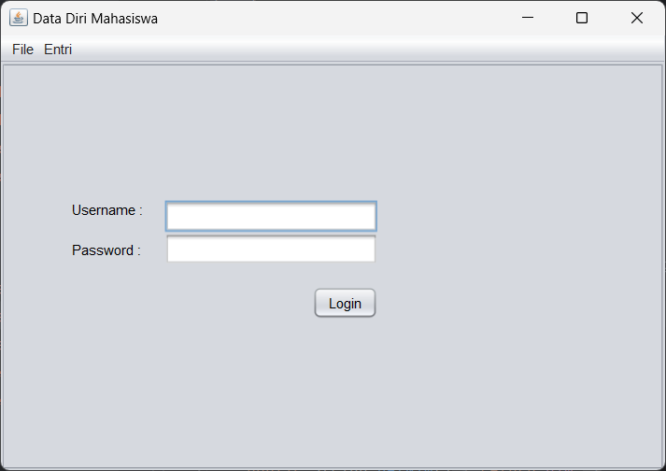

1. Home

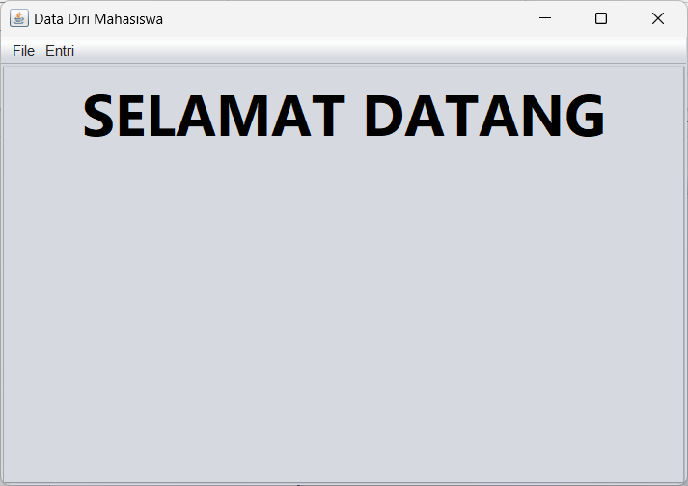

1. Tampil mahasiswa pada JTable

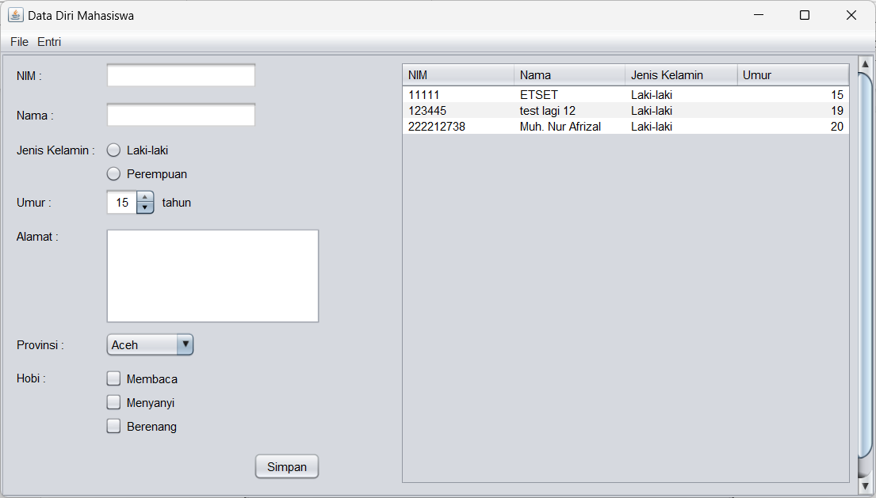

1. Tambah mahasiswa

